Interface ID: OL-2
Created by: Mark Lund
Created Date: 10-2-2005

Description of Design Concept:
The Tabs and Decal web applications currently store finalized transactions in transaction tables in their respective tables in vsIPO. The finalized transactions are subsequently integrated to the VFS database via batch integration processes that are scheduled to run every minute throughout the day. A new Windows Service (vsdVFSDatabaseIntegration) will replace the batch processes.

The vsdVFSDatabaseIntegration service will be running throughout the day and will read the web application transaction tables looking for records that have been finalized, but have not been integrated. If night batch is not running, the service will copy the records to the new Field System database using a View with matching field names. A Delivery Key will also be inserted in the appropriate Field System database if necessary. Upon successful integration into the Field System, the transaction record integration attribute will be set on. If records are ready for integration but night batch is running, the service will sleep a configurable amount of time before attempting to integrate the records.

Decomposition/Flow Diagram:
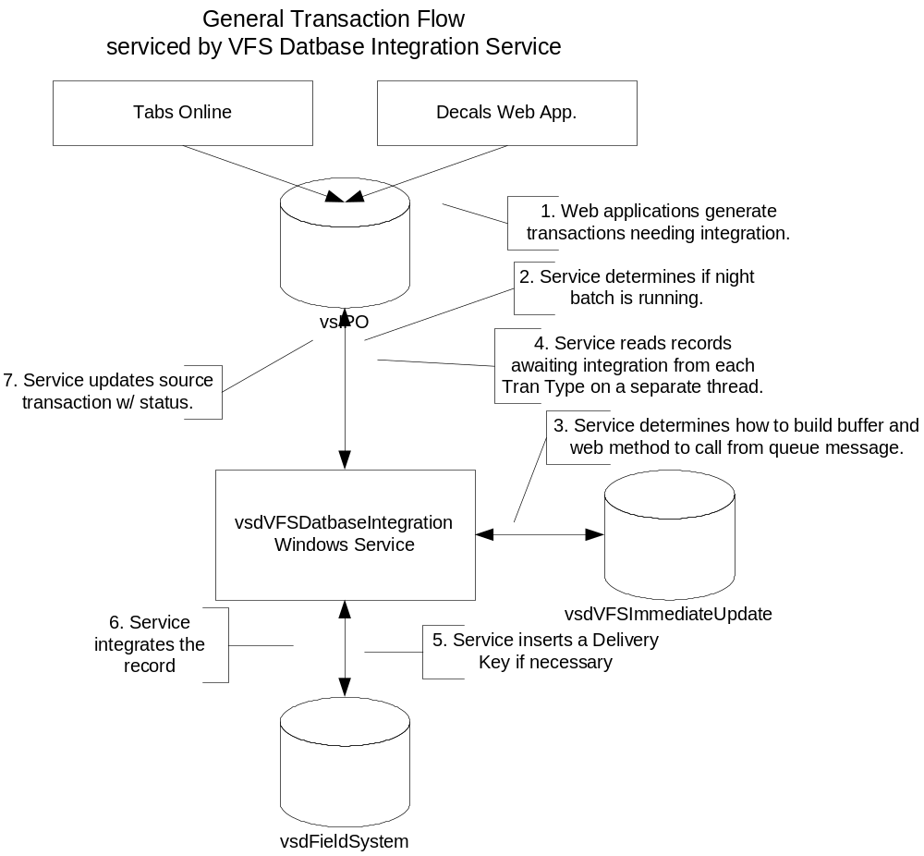

Functional Specifications:

Functionality:

- Web apps. generate records in SQL that need integration to the Field System.
- The service spawns a thread for each unique TranType (REN and BREN) value in it’s buDBIntegrationTranType table.
- If night batch is running, the service will wait sleep a configurable amount of time before attempting any integration.
- Using parameters in the buDBIntegrationTranType table, the service is able to determine which stored procs. are necessary to locate records, integrate Field System records, and update the source record.
- If the target Delivery Key table (buVehicleDeliveryKey or buVesselDeliveryKey) does not contain a value for the record, the service will insert it before integrating the record.
- The service integrates (copies) the record from the source database to the target database.
- If the status is successful, the service updates the appropriate vehicle or vessel transaction record in the vsIPO database.

Appendix A: Database Tables
Table: utAppConfig: the table would be used to define application processing and configuration parameters.
Attribute Name | Type | Length | Description
Process | Varchar | 50 | The name of the process a set of parameters is for.
Name | Varchar | 50 | The name of a parameter the calling process is interested. Process & Name create a unique parameter.
Value | Varchar | 255 | The parameter value
Comment | Varchar | 255 | Description of the parameter and how it is utilized.
Table: buDBIntegrationTranType: this table defines the transaction types and associated processing details.
Attribute Name | Type | Length | Description
Process | Varchar | 50 | The name of the process a set of parameters is for.
TranType | Varchar | 8 | The transaction type of the record written being integrated.
SourceConnect  StringKey | Varchar | 50 | Connect string key for the source (vsIPO) database.
DestinationConnect  StringKey | Varchar | 50 | Connect string key for the dest (vsdFieldSystem) database
SPSelName | Smallint | 50 | SP name used to obtain records needing integration from the source (vsIPO) database.
SPUpdName | Tinyint | 50 | SP name used to update the successfully integrated source record.
SPSelParamName | Varchar | 50 | Parameter name used by the update procedure to locate the record that was integrated.
SPSelDeliveryKey  Name | Varchar | 50 | Database update stored procedure name.
SPSelDeliveryKey  ParamName | Varchar | 50 | The name of the key used by the update stored proc.
SPInsTransactionName | Varchar | 50 | Not used by this process.

